## **What is a Networking Model?**

Networking models categorize and provide a structure for networking protocols and standards.

*(Protocols are a set of logical rules defining how network devices and software should work.)*

## **OSI MODEL**

* Open Systems Interconnection Model
* Conceptual model that categorizes and standardizes the different functions in a network.
* Created by the "International Organization for Standardization" (ISO)
* Functions are divided into 7 "Layers."
* These layers work together to make the network work.

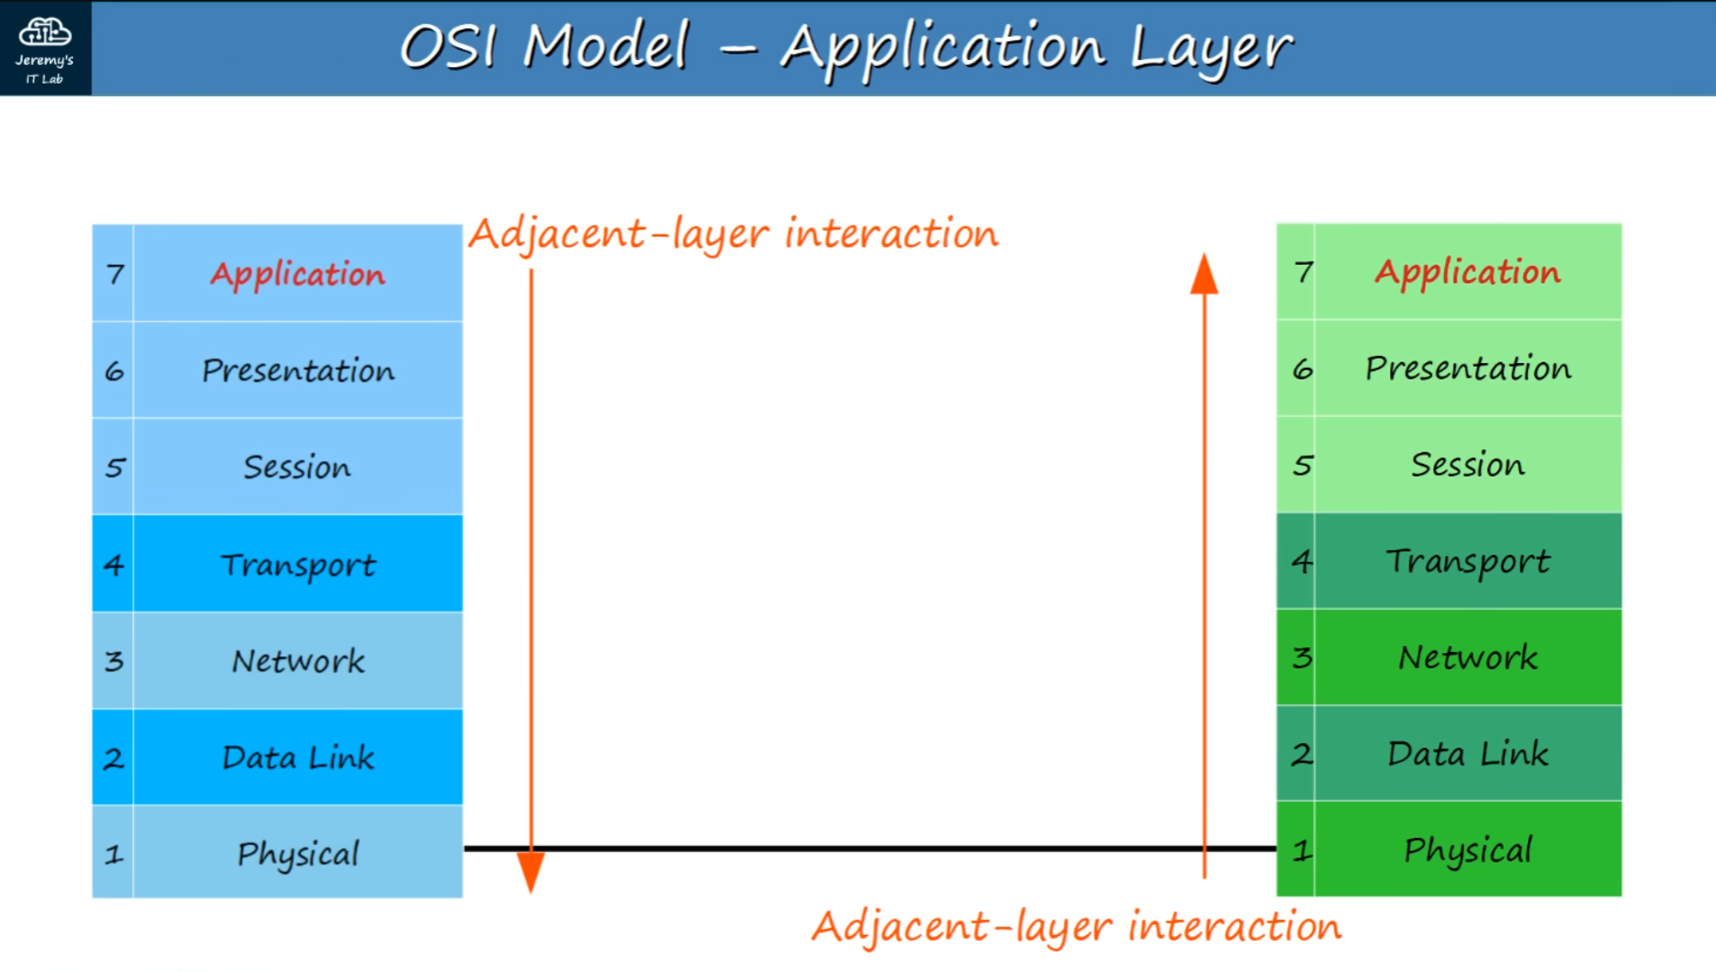

As data moves from the top layer, downward, the process is called **encapsulation.**

As data moves from the bottom layer, upward, the process is called **de-encapsulation.**

When interactions occur on the same layer, it’s called **same-layer interaction.**

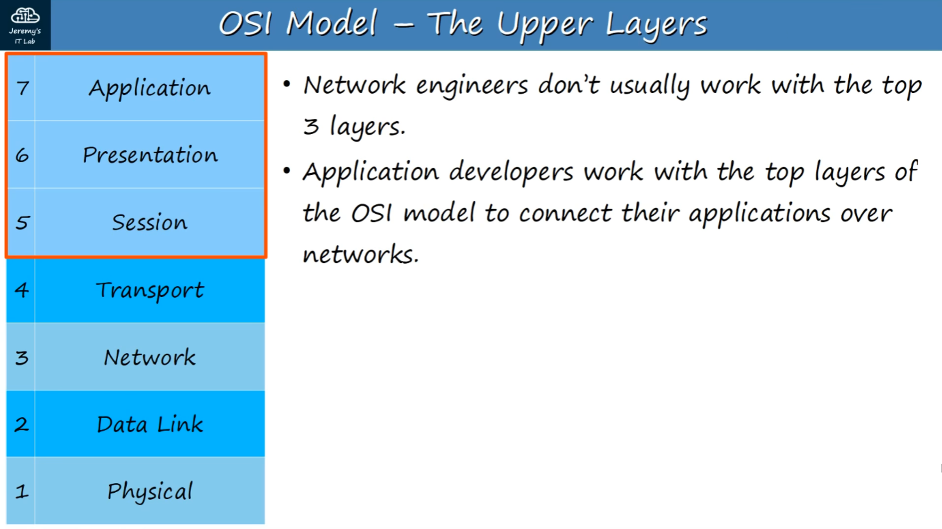

**Mnemonic to help remember the Data Layer Names / Order:**

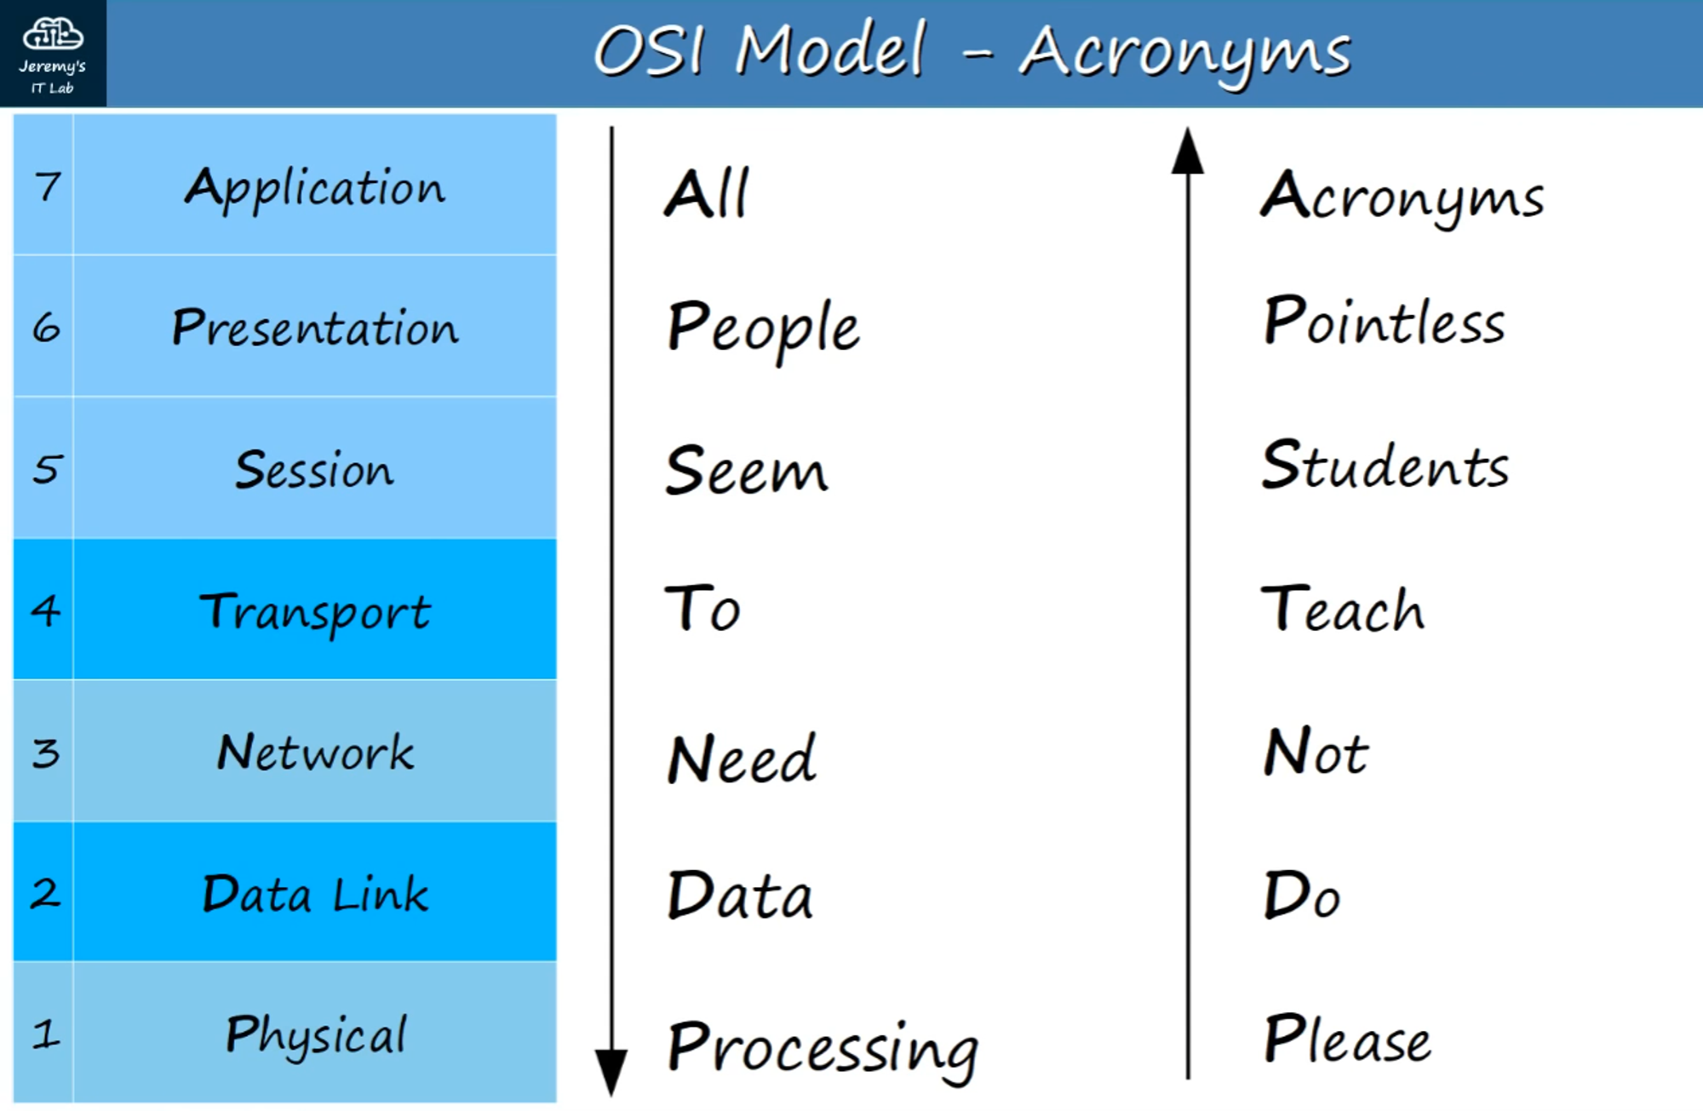

### **The Layers Are:**

### **7 - APPLICATION**

* Closest layer to the end user.
* Interacts with software applications.
* HTTP and HTTPS are Layer 7 protocols.

Functions of Layer 7 include:

* Identifying communication partners
* Synchronizing communication

### **6 - PRESENTATION**

* Translates data to the appropriate format (between Application and Network formats) to be sent over the network.

### **5 - SESSION**

* Controls dialogues (sessions) between communicating hosts.
* Establishes, manages, and terminates connections between local application and the remote application.

**Note:** Network engineers don't usually work with the top three layers.  
 Application developers work with these top layers to connect applications over networks.

### **4 - TRANSPORT**

* Segments and reassembles data for communication between end hosts.
* Breaks large data pieces into smaller segments, reducing transmission issues if errors occur.
* Provides HOST-TO-HOST (end-to-end) communication.

When Data from Layers 7-5 arrives, it receives a Layer 4 Header in the Transport layer:

<< DATA + L4 Header >>

This is called a **SEGMENT.**

### **3 - NETWORK**

* Provides connectivity between end hosts on different networks (e.g., outside the LAN).
* Provides logical addressing (IP Addresses).
* Provides path selection between source and destination.
* **ROUTERS** operate at Layer 3.

When Data and the Layer 4 Header arrive in the Network Layer, it receives a Layer 3 Header:

<< DATA + L4 Header + L3 Header >>

This is called a **PACKET.**

### **2 - DATA LINK**

* Provides NODE-TO-NODE connectivity and data transfer (e.g., PC to Switch, Switch to Router).
* Formats data for transmission over physical medium (e.g., copper UTP cables).
* Detects and (possibly) corrects Physical (Layer 1) errors.
* Uses Layer 2 addressing, separate from Layer 3 addressing.
* **SWITCHES** operate at Layer 2.

When the Layer 3 Packet arrives, a Layer 2 Trailer and Header are added:

<< L2 Trailer + DATA + L4 Header + L3 Header + L2 Header >>

This is called a **FRAME.**

All the steps leading up to transmission are called **ENCAPSULATION.** When the frame is sent to the receiver, it goes through **DE-ENCAPSULATION**—stripping off layers while traveling from Layer 1 to Layer 7.

### **1 - PHYSICAL**

* Defines physical characteristics of the medium used to transfer data between devices (e.g., voltage levels, connectors, cable specs).
* Converts digital bits into electrical (wired) or radio (wireless) signals.
* All of the information in **Section 2 (Networking Devices)** relates to the Physical Layer.

## 

## 

## **OSI MODEL - PDUs**

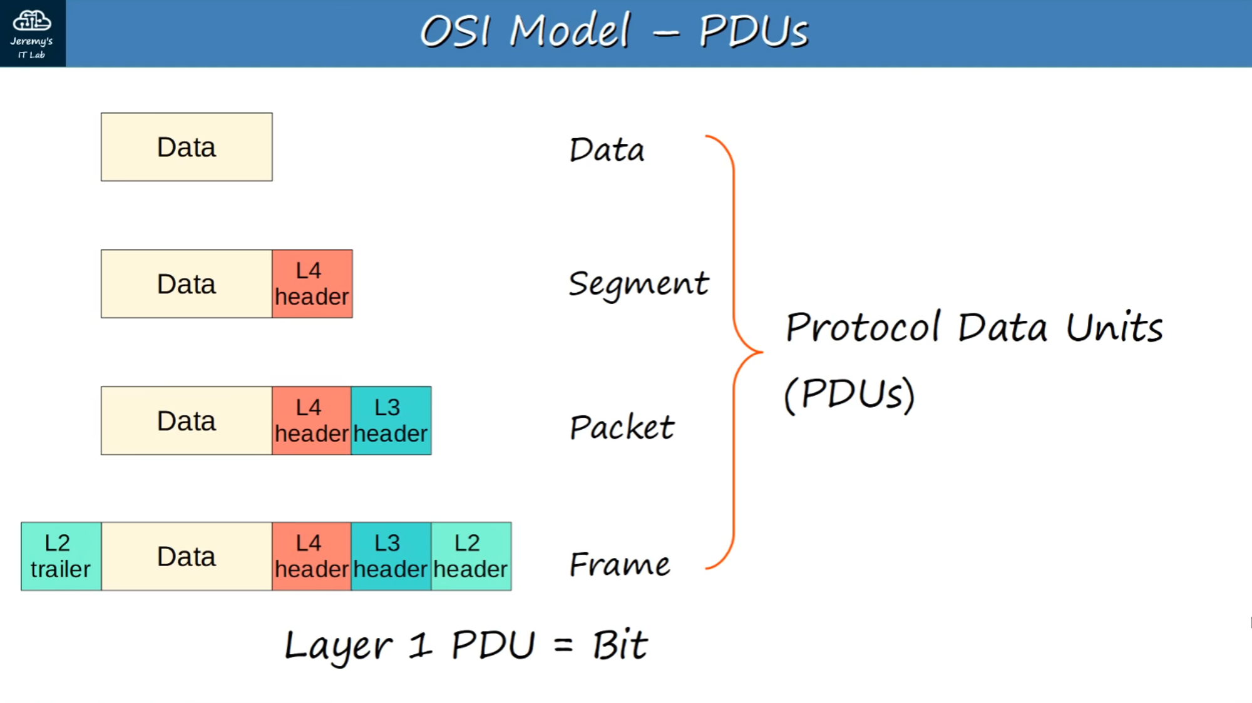

A **PDU** is a Protocol Data Unit. Each step of the process is a PDU:

| **OSI Layer** | **PDU Name** | **Protocol Data Added** |
| --- | --- | --- |
| 7-5 | DATA | Data |
| 4 | SEGMENT | Layer 4 Header Added |
| 3 | PACKET | Layer 3 Header Added |
| 2 | FRAME | Layer 2 Trailer + Header |
| 1 | BIT | Transmission as 0s and 1s |

## **TCP/IP Suite**

* Conceptual model and set of communications protocols used in the Internet and other networks.
* Known as **TCP/IP** because those are two foundational protocols in the suite.
* Developed by the US Dept. of Defense via DARPA (Defense Advanced Research Projects Agency).
* Similar structure to the OSI Model, but fewer layers.
* **This is the model actually in use in modern networks.**
* *Note:* The OSI Model still influences how network engineers think and talk about networks.

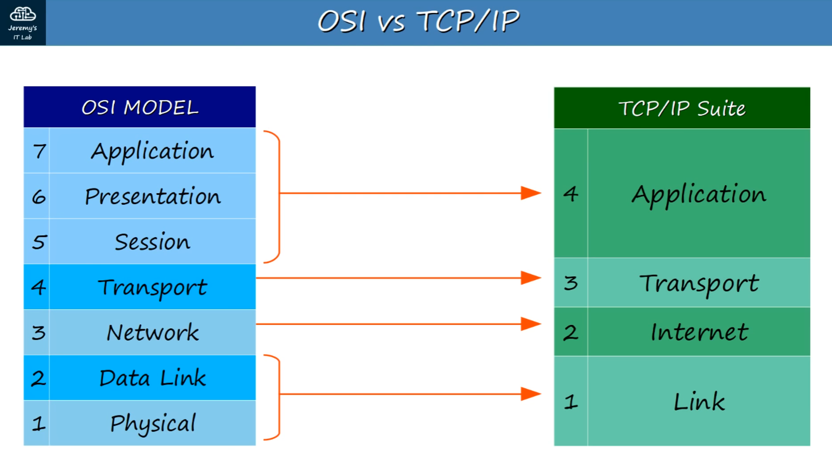

### **Layer Interactions**

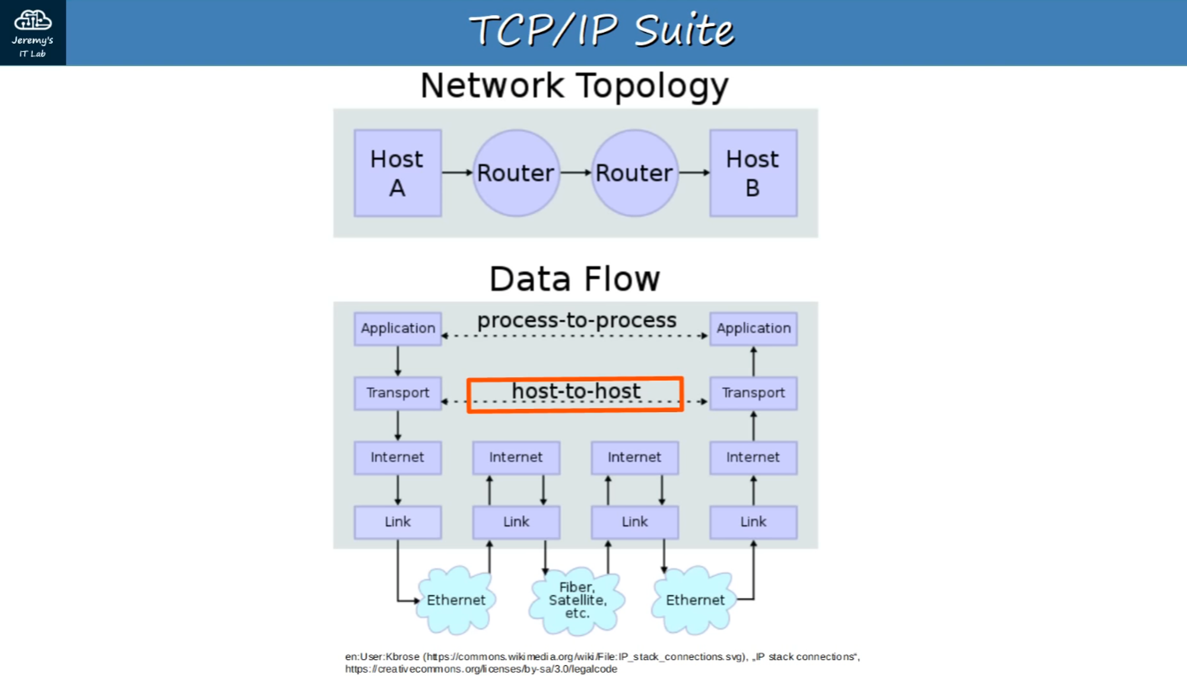

**Adjacent-Layer Interactions**

* Interactions between different layers of the OSI Model on the same host.

*Example:* Layers 5-7 sending data to Layer 4, which then adds a Layer 4 header (creating a SEGMENT).

**Same-Layer Interactions**

* Interactions between the same layer on different hosts.
* This allows you to focus on the interaction of a single layer across devices.

*Example:* The Application Layer of YouTube's web server and your PC's browser.